**Everyday Cell Model**

A eukaryotic animal cell consists of numerous smaller organelles that provide vital functionality to the cell as a whole, and by their powers combined, form a functional whole. When looking at these cells through a microscope, the first organelle that we are likely to see is the cell membrane, so that is where we will begin. A cell membrane has two primary functions. The first is to keep the interior of the cell separate from the exterior environment. The second is to regulate and facilitate the passage of various molecules into and out of the cell. I believe my trusty lunchbox is a nearly perfect representation of this vital structure. Its primary purpose is to protect the interior contents (other organelles and structures for the cell, delicious sandwiches for the lunchbox) from the harsh external environment. It also allows the passage of materials into and out of its protective embrace. To further the analogy, the structure of the lunchbox has an inner and an outer layer, just like the phospholipid layer that makes up the cell membrane. All in all, the lunchbox is an excellent building block for our functional cell model.

*Behold, the humble lunchbox. Protector of cells and sandwiches alike.*

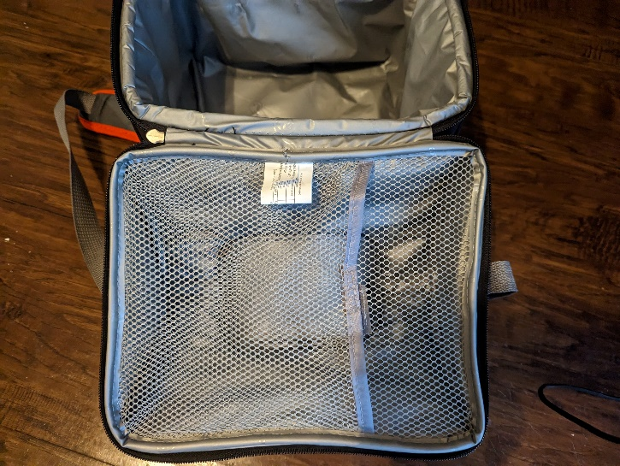There are two components that are closely related to the membrane. The first is the cytoskeleton. This structure provides two functions to the cell. The first is that it provides structure to the cell, and the second is that the various filaments that make up the cytoskeleton serve as highways that proteins use to transport themselves and other materials around the cell. Thankfully, my membrane of choice comes equipped with a mesh divider, which provides structural support and could serve as a pathway for any pesky insect invaders.

The second membrane adjacent component is the cytoplasm. This is the liquid interior of the cell which serves as the living environment for the rest of the organelles. As the cytoplasm is composed mostly of water, the easy real-world equivalent would be to simply fill my cell membrane with water. However, my lunchbox has seen better days, and filling it with water would only serve to provide an excellent demonstration of cell death. So, I humbly request that the reader simply imagine that my model is waterproof and filled with only the finest fresh spring water.

Our next organelle is the nucleus. The nucleus serves as the brain of the cell, storing the instructions in the form of DNA which are then given to the rest of the cell in the form of messenger RNA. The nucleus is surrounded by its own membrane, with pores that allow the passage of information to the rest of the cell. In what will probably be a popular choice for this exercise, the best representation that I found for the nucleus is external computer memory, such as a USB drive, or in my case, an external hard drive. This hard drive has an outer protective membrane (plastic case), pores that enable the delivery of information out of the device (the cable), and non-volatile memory that stores vital information (like DNA).

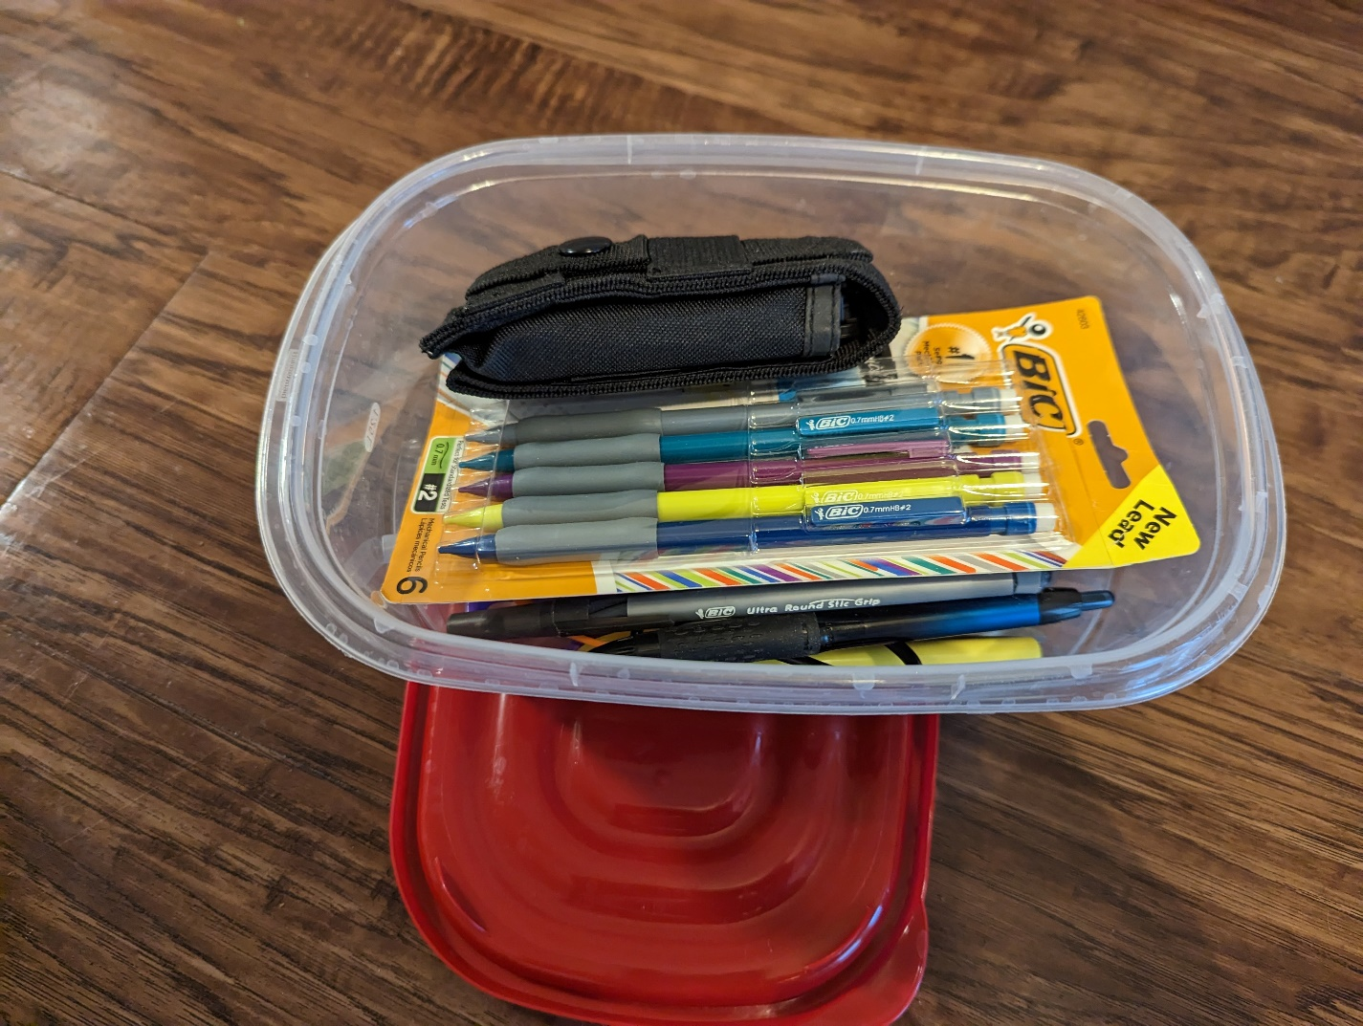The endoplasmic reticulum serves a variety of functions in the cell. It has a role in protein synthesis, lipid metabolism, steroid production, and detoxification. The rough ER is covered in ribosomes and focuses on protein synthesis, while the smooth ER lacks ribosomes and is responsible for the other functions, depending on the cell type. This organelle will be represented by a small arts and crafts kit. By size, it will be the largest of the interior organelles and is responsible for creating the various pieces needed by the rest of the cell.

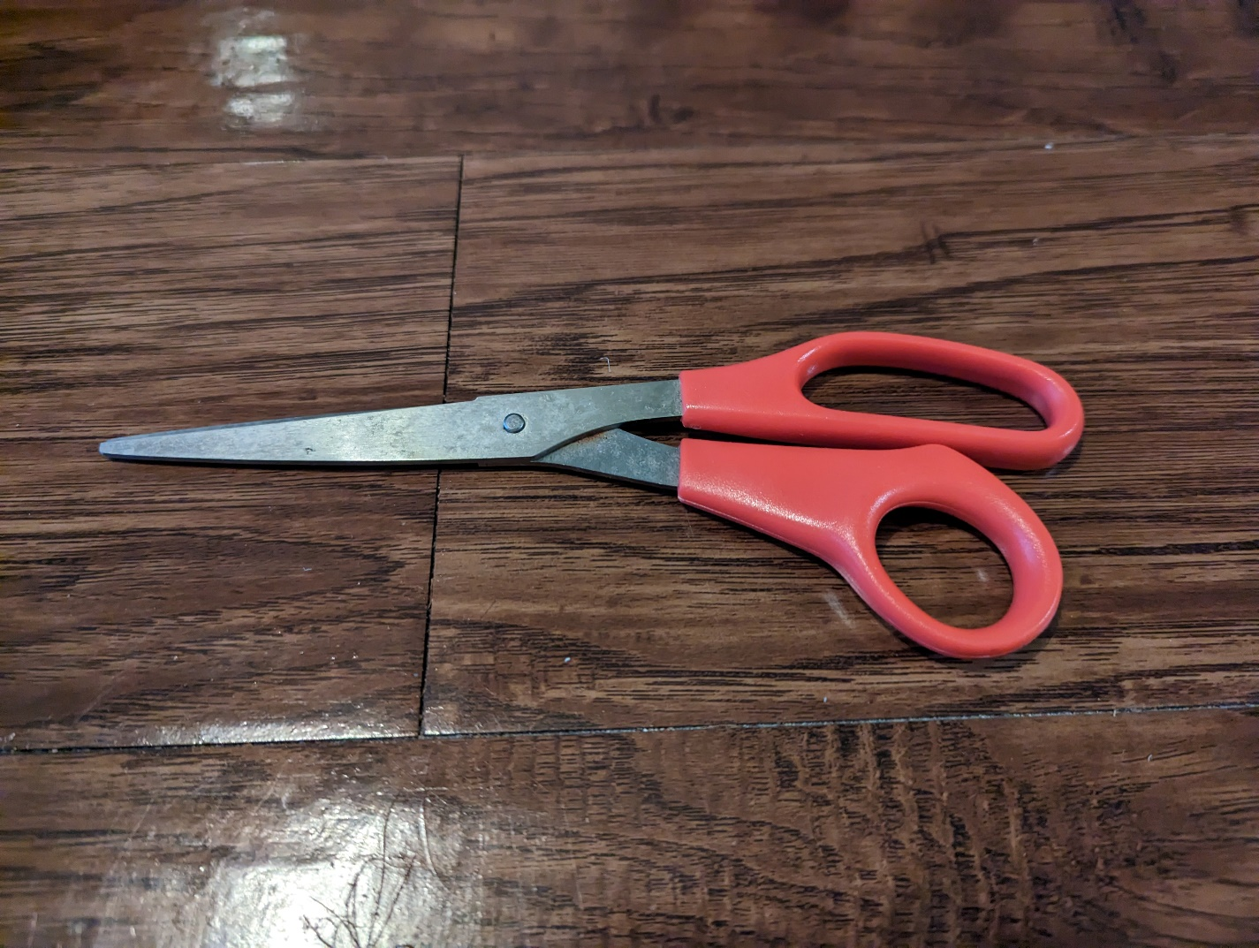Ribosomes are responsible for translating mRNA strands into polypeptide chains, which then fold and assemble themselves into proteins. They can be found floating around the cytoplasm and also attached to the rough ER. This model will use a pair of scissors to represent ribosomes. As many a kindergartner has learned, scissors are capable of assembling various structures (proteins) out of their constituent parts.

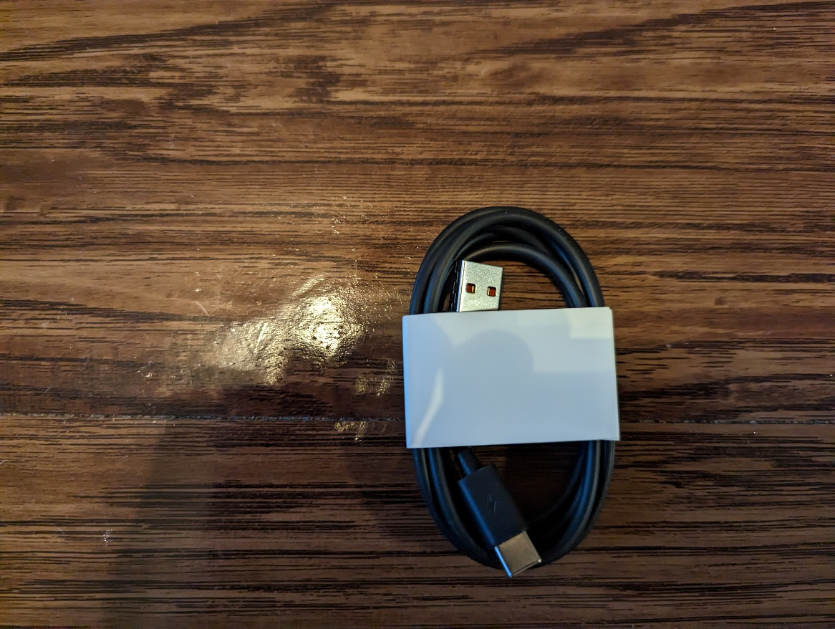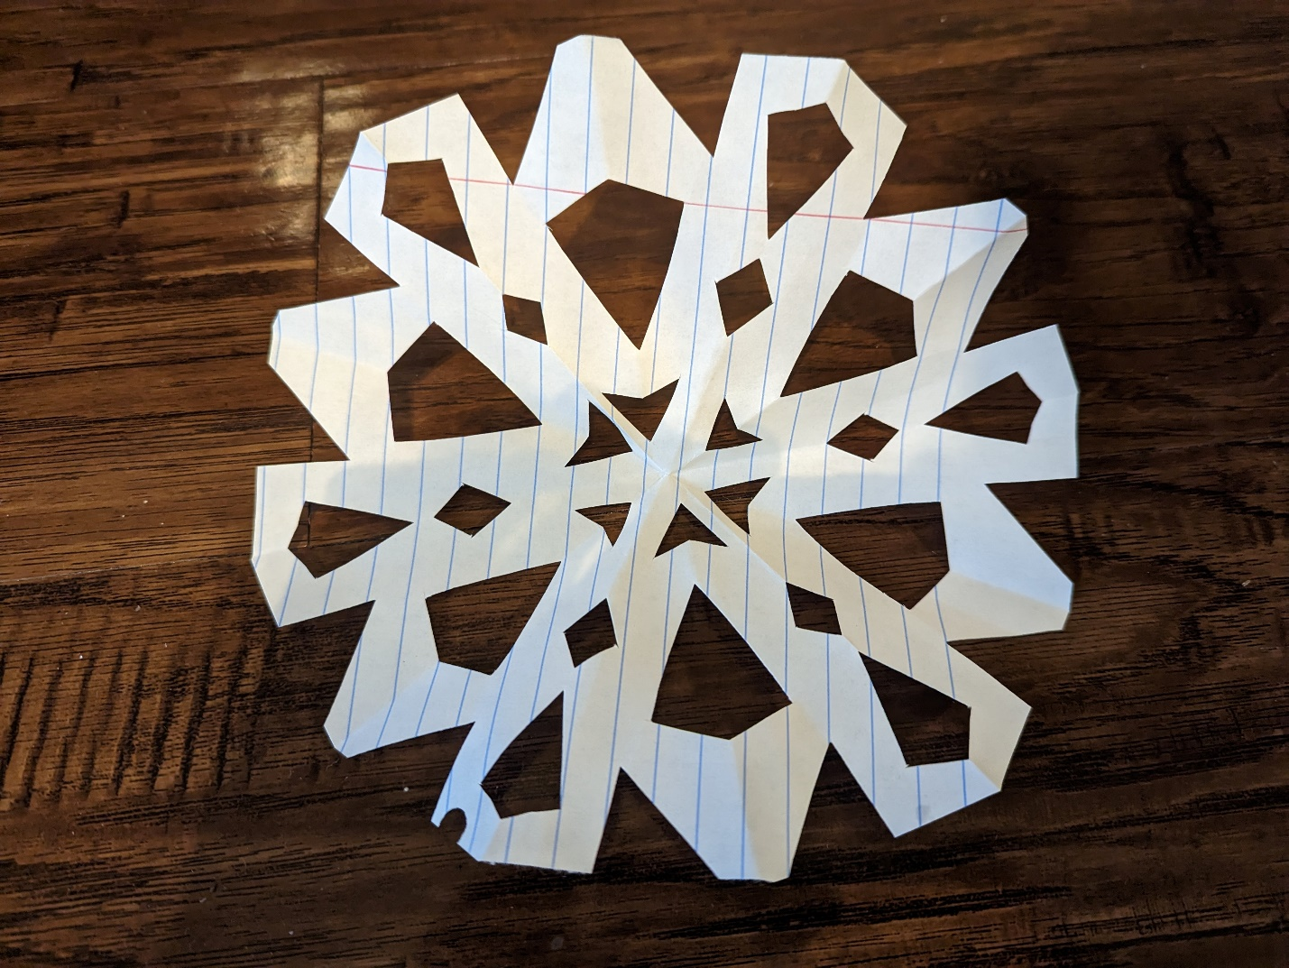Located close to the ER, the Golgi apparatus is responsible for putting the finishing touches on proteins produced by the ER, and then sending them on their way to their final destination. The transportation to and from the Golgi is accomplished via bubble-like vesicles. In my model, this is represented by a computer cable, specifically one that converts input from one form to another. This cable takes in packets (vesicles) of information, transforms it to its final form, and then sends the new packets to its destination.

*A protein!*

Mitochondria, the powerhouse of the cell (Note: I am a child of the 90’s and I am honor-bound to repeat this phrase anytime mitochondria are discussed). The primary function of these organelles is to perform cellular respiration, converting glucose into adenosine triphosphate, a form of energy that can be used by the rest of the cell. A single mitochondrion is functionally its own self-contained cell. It has a membrane and DNA in a unique, circular shape. To represent this vital organelle, I choose the most obvious substitute, a battery. A battery has its own membrane, the outer casing that keeps the insides on the inside. And its primary purpose is to convert one form of energy (chemical) into a form that is usable by other devices.

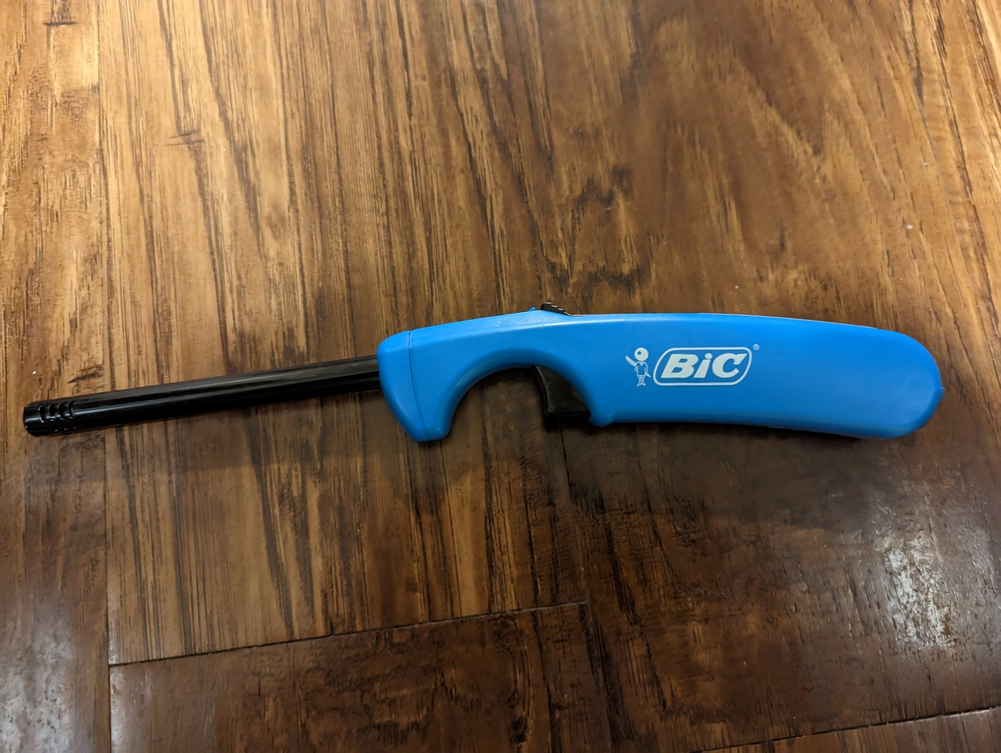Lysosomes are the digestive system of individual cells. The break down various substances and malfunctioning or otherwise broken pieces of the cell into its base components. These components are then available to be reused in the creation of new organelles. This function will be replicated by a lighter. As a famous book once said, “ash to ash, dust to dust.” The lighter will take a defunct organelle or other structure and break it down to its base components (carbon in this case).

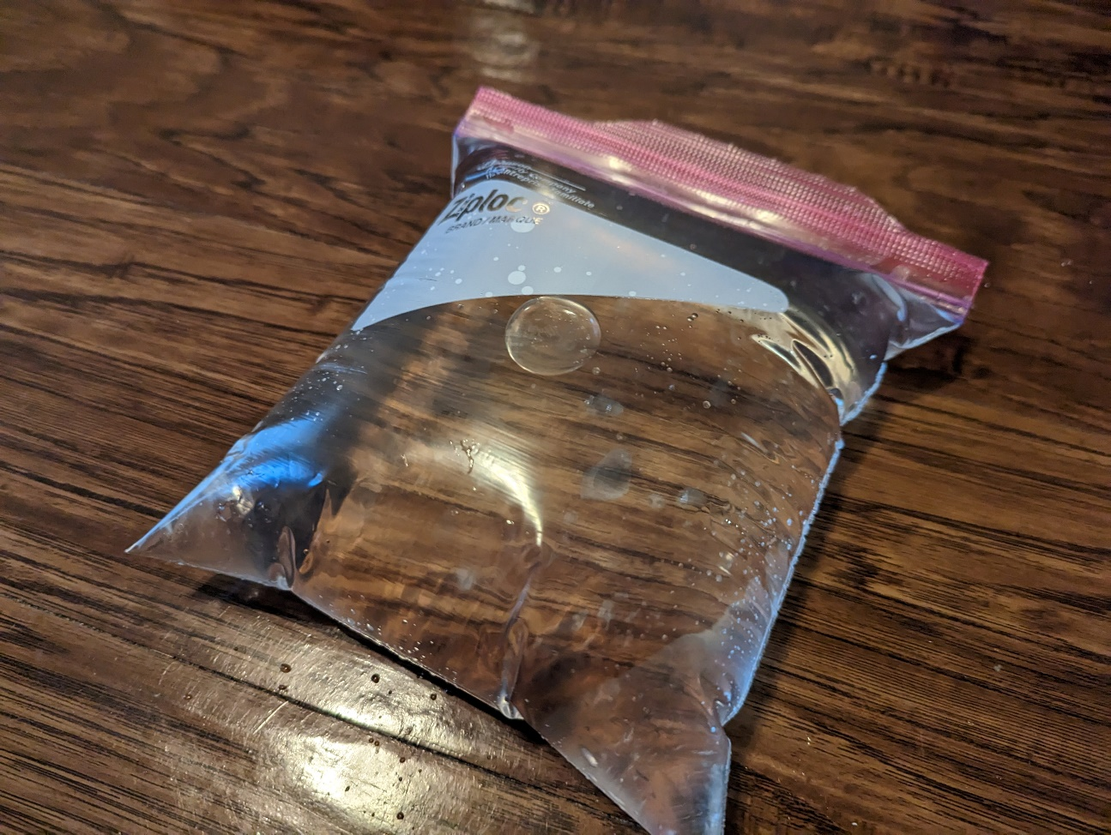The final organelle that we’ll add to the model will be the vacuole. This structure is typically found in plant cells but can be found in some animal cells. This structure serves as storage for the cell. These contain mostly water with some inorganic and organic molecules mixed in. This will be modeled by a simple Ziplock bag filled with water. This bag stores the water and other unspeakable molecules from my tap water and separates it from the rest of the cell.

This concludes our tour of a function cell model. I leave you with the final assembled cell in all its glory.